**Philadelphia University**

**Faculty of Information Technology**

**Department of Software Engineering**

**Examination Paper**



**Lecturer : Ms. Enas Al-Naffar**

**Coordinator : Ms. Enas Al-Naffar**

**Internal Examiner: Dr. Mourad Maouche**

**Software Requirements (721230) First Exam Time**: **50 Minutes**

**Information for Candidates**

1. *This examination paper contains 4 questions. The total is 20.*
2. *The marks for parts of questions are shown in round brackets.*

***I. Basic Notions***

*Objectives: The aim of the question is to evaluate your knowledge and skills concerning with the basic concepts of* ***Computing Ethics***

**Question 1: [7 Marks]**

A- Requirements engineering is considered to be the most important part of Software engineering. Why? (2 marks)

* It forms the basis for all the software development activities.
* Requirements guide the software development process; "if you don't know where you are heading, you are unlikely to end up there".

B- What do we mean by the term "Software Quality" ? What is the relationship between Software Requirements and software Quality? [3 Marks]

Software Quality means fitness for purpose.

The better the software requirements, the higher the quality.

C- What does Requirement Tractability mean? [2 Marks]

Understanding how high level requirements are transformed into low level requirements.

### *II. Familiar Problems Solving*

### *Objectives: The aim of the question is to evaluate your basic knowledge of the key aspects of the lectures material and your ability to solve familiar problems.*

**Question 2: [2 Marks, 1 Mark each]**

A Support system is being developed to help a customer service center department doing their job. Classify the following into Objectives and Software Requirements.

1. The system should increase efficiency and performance of the employees. objective
2. The system should allow users to record phone calls for further analysis. Req

**Question 3: [8 marks]**

Consider the following case study, and then answer the following questions:

The Library System is a web-based application that will interoperate with the university system. It allows the librarian to maintain the information about book and users. Only registered users can use the system. The system provides a search option which allows users to search for any item in the library. If the user finds that the required item is available, he/she can checkout the item from the library. If the item is currently not available, the user can make reservation for the item. When the item becomes available the respective user who made the reservation for that item first is notified. The reservation is canceled when the user checks out the item from the library or through an explicit cancellation procedure.

1- Draw a context diagram for the library system. (3 marks)

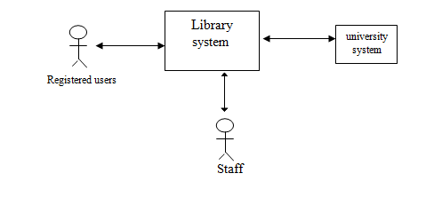

2- Write down three Functional Requirements of the library system (3 Marks).

-The system shall allow users to search for items based on title, author name or topic.

-The system shall display search results where the closest item to the search criteria shall appear on top.

-The system shall allow users to reserve items if they are not available.

3- Write down two non-functional requirements of the library system. (2 marks)

- interoperability : the library system shall interoperate with the university system

- Security: Only registered uses can use the library system.

***III. Unfamiliar Problems Solving***

Objectives: *The aim of the question is to evaluate your knowledge of the key aspects of the lectures material and your ability to solve unfamiliar problems.*

**Question 4: [3 marks]**

Think about one problem that may arise due to using Functional requirements using the following style : "The system shall ...... ".

Using this style may sometime impose some design constraints

Good Luck ☺